1. Sample Preparation
2. Materials

* Sample tissue (muscle homogenate or single fiber prep)

a MHC extraction buffer (This sample buffer is adapted from Tikunov et.al., 2001,paper attached to the wiki page.)

* + 50 mL 2x solution:
    - 1.419 g KCl: Sigma, P4504-500G
    - 1.3606 g KH2PO4: Sigma, P5379-100G
    - 0.8710 g K2HPO4: Sigma, P3786-100G
    - 0.2922 g EDTA: Acros, 118432500
    - 0.4461 g Na4O7P2: Sigma, 221368-100G
    - 28 µL 2-mercaptoethanol: Bio-Rad, 161-0710
    - Adjust pH to 6.5 using KOH: Fisher, P250-1
    - 500 µL Protease Cocktail Inhibitor: Sigma, P8340
* 10% stock Triton X-100: Thermo, 28314
* Working Laemmli Sample Buffer
  + 950 uL Laemmli Sample Buffer: Bio-Rad, 161-0737
  + 50 uL Beta-mercaptoethanol: Bio-Rad, 161-0710
* Glycerol: Fisher, G33-1
* 1.5 mL eppendorf tube
* Heating block
* Automated shaker

1. Method
2. Muscle homogenates

Dissect/weigh out 0.01 grams of the sample tissue and finely chop/mince it up with a razor blade. Nest the homogenate into the bottom of an eppendorf tube. Place eppendorf tube rack in ice and places the tube in the rack. Add 50 µL of MHC extraction buffer and then add 50 µL of triton to the bottom of the tube. Place the rack into the shaker in the left fridge and let the samples sit overnight (maximum of 24 hours).

The next day, take the rack out of the fridge and put the tubes directly into ice. **Turn on the heating block and set the temperature to 102º C**. Place a couple of eppendorf tubes with glycerol in the heating block. Label an equivalent number of new eppendorf tubes and add to them 20 µL of the sample supernatant. **Add 80 µL of Working Laemmli Sample Buffer** and **vortex the tube**. Once the heating block has reached 100º C, **add 30 µL of the heated glycerol**. Make sure to lavage the solution when adding the glycerol. With the heating block still at 100º C, place the tube into the **heating block for 4 minutes**.

Following the heating process, place the tube **on ice for 10 minutes**. Once this has been completed, the samples are ready to be loaded. Any excess supernatant can be stored in the -20º C freezer (short term storage) or -80 º C freezer (long term storage) by adding 80 µL of glycerol.

1. Single fiber preps

A single muscle fiber should be nested into the bottom of an eppendorf tube (this will already be done by whoever did the mechanics on the prep). The eppendorf tube should a 0.5 mL tube and you should make sure the prep is in the bottom of the tube (check it under the dissecting scope).Place eppendorf tube rack in ice and place the tubes in the rack. **Add 10 µL of MHC extraction buffer** and then **add 10 µL of triton**. Place the tube into the shaker in the left fridge overnight (maximum 24 hours).

The next day, take the samples out of the fridge and put them on ice. At this point, turn on the heating block and set the temperature to 102º C. Place a couple of eppendorf tubes with glycerol in the heating block. Once the temperature reads 100°C, **add 20 µL of Working Laemmli Sample Buffer** to each eppendorf tube (with the single fiber and extraction buffer), **add 12 µL of the heated glycerol**, and then **vortex** the tube. Make sure to lavage the solution when adding glycerol.

Afterwards, place the tube into the **heating block for 4 minutes**. Then, place the tube on **ice for 10 minutes**. Once this has been completed, the samples are ready to be loaded.

Gel Assembly

1. Materials

* High vacuum grease: Dow Corning 2966K52
* 70% ethanol
* 2 glass plates (10 cm x 10.5 cm): Hoefer, Inc. SE262P-5
* 2 notched glass plates (10 cm x 10.5 cm): Hoefer, Inc. SE202GN-5
* 4 T spacers (12 cm x 0.75 mm): Hoefer, Inc. SE2819T-2-.75
* 2 casting clamp assemblies: Hoefer, Inc. SE249
* 4 cams (black): Hoefer, Inc. part of SE245
* 4 clips (small): Hoefer, Inc. part of SE245
* 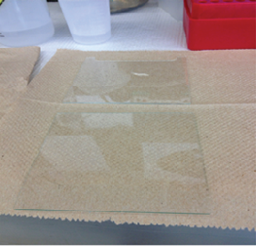Dual gel caster: Hoefer, Inc. SE245

1. Methods
2. Cleaning Gel Sandwich Plates

Both the glass and notched glass plate should be cleaned, prior to gel sandwich assembly, using 70% ethanol. Spray the solution on a Kim wipe and clean off any residue. Align the plates end-to-end (as shown) prior to adding the spacers, as the glass plate’s orientation must match that of the notched glass plate.

1. 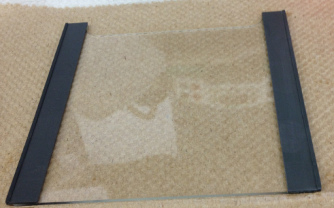Application of Vacuum Grease

Apply vacuum grease to both sides of a T spacer and position it onto one side of the notched glass plate. Do the same for the other side. Take care not to accidentally get vacuum grease on the clean glass surface. Wipe off any residual grease with a kim wipe and 100% methanol.

1. Final Assembly

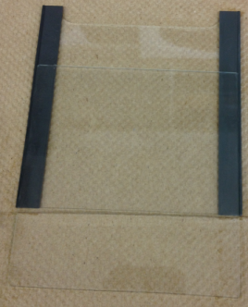Place the glass plate about half way on top of the notched glass plate. Use the spacers as a guide. If the spacers were put on correctly, then the glass plate should simply slide into place. With the glass plate half in place, slide it forward until the top of the sandwich (the notched end) is completely aligned. Grease will have come off in the process, so wipe off any residual grease from the top of the gel sandwich.

1. 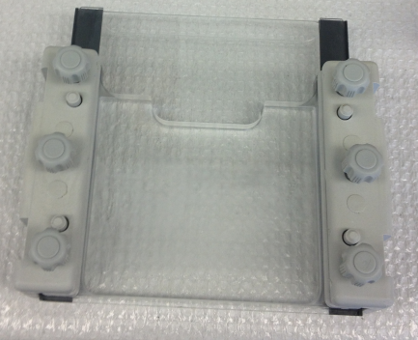Dual Gel Caster

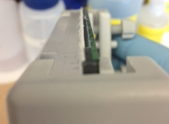Slide each completed gel sandwich into a casting clamp assembly with the notched glass plate side facing away from the screws. Insert the gel sandwich only half way and pull from the notched end until the bottom portion (with the grease) **is approximately 3 mm** from the casting clamp assembly. Apply vacuum grease to the bottom of the sandwich (the side without notches). Tighten the screws on the casting clamp assembly until each gel sandwich is secured.

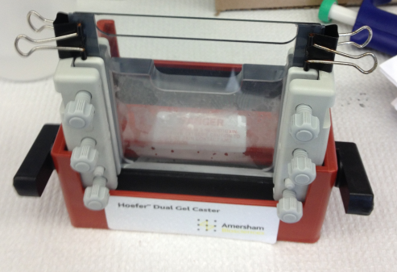Wipe down the dual gel caster with 100% methanol and place the casting clamp assembly into the dual gel caster. Push down on the side of the casting clamp assembly in order to fit a cam into a hole on each side of the caster.

Finally, place a small clip onto each side of the exposed (notched) side of the gel sandwich.

1. Test Seal

To test the seal, pipette a small amount of 70% ethanol into the cavity of the gel sandwich. If there are no leaks after approximately 10 minutes, then pour out the ethanol so that the resolving gel may be poured.

1. Resolving Gel Preparation
2. Materials

* 15 mL falcon tube
  + 4.300 g 86-88% glycerol: Acros, 295600010
  + 1.300 mL DI H2O
  + 1.715 mL 40% acrylamide: Bio-Rad, 161-0140
  + 0.700 mL 2% Bis: Bio-Rad, 161-0142
  + 1.333 mL 1.5 M Tris-pH 8.8: Bio-Rad, 161-0798
  + 1.000 mL 1 M glycine
    - 75.0666 g glycine: MP, 808831
    - 1 L DI H2O
  + 0.400 mL 10% SDS: Bio-Rad, 161-0416
* 55 µL 10% APS
  + 2 mL eppendorf tube
    - 0.1 g APS: Sigma, A3678-25G
    - 1 mL DI H2O
* 6 µL TEMED: Bio-Rad, 161-0800
* 400 µL n-butanol
  + 25 mL n-butanol: Fisher, BP505-500
  + 25 mL DI H2O

1. Methods

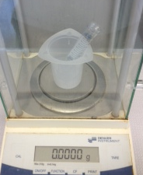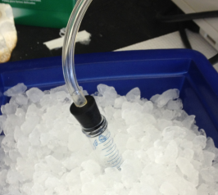Due to the high viscosity of glycerol, the liquid can be measured in terms of mass, instead of volume (see picture to the left).

Invert the falcon tube several times to ensure that the reagents mix well. Next, attach the tube to the vacuum line via the special tube cap, place it on ice, and degas the resolving gel solution for 45 minutes.

After 45 minutes has elapsed, add 55 µL of 10% APS (made fresh) and 6 µL of TEMED. Cap the tube and invert it once more until the solution appears homogenous. Using a plastic transfer pipette, pour the resolving gel into the gel sandwich assembly until the solution level is about an inch past the notch in the casting clamp assembly. With the resolving gel poured, add 400 µL of n-butanol to the gel and allow **one hour for the gel to polymerize.**

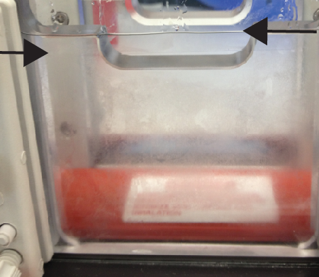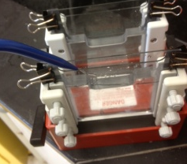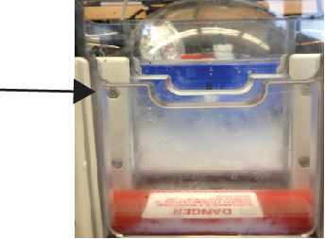After an hour, check the gel’s polymerization. If the gel has polymerized properly, pour the n-butanol down the sink by inverting the entire casting clamp assembly. Rinse the gel with DI H2O four times and then rest the assembly upside down to dry.

1. Stacking Gel Preparation
2. Materials

* 15 mL falcon tube
  + 2.150 g 86-88% glycerol: Acros, 295600010
  + 0.525 mL 40% acrylamide: Bio-Rad, 161-0140
  + 0.210 mL 2% Bis: Bio-Rad, 161-0142
  + 0.700 mL 0.5 M Tris-pH 6.8: Bio-Rad, 161-0799
  + 0.200 mL 100 mM EDTA
    - 14.6115 g EDTA: Acros, 118432500
    - 500 mL DI H2O
  + 1.422 mL DI H2O
  + 20 µL 1% bromophenol blue
    - 0.01 g Bromophenol Blue: Sigma, B5525-5G
    - 10 mL DI H2O
  + 0.100 mL 10% SDS
* 30 µL 10% APS
* 13 µL TEMED
* 2 Teflon combs, 10 well (0.75 mm): Hoefer, Inc. SE511-10-0.75

1. Methods

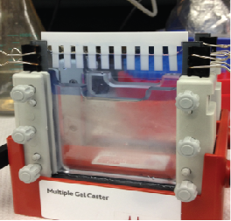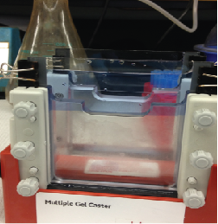Invert the falcon tube several times to ensure that the reagents mix well. Next, attach the tube to the vacuum line via the special tube cap, place it on ice, and degas the stacking gel solution for 25 minutes.

After 25 minutes, add 30 µL of 10% and 13 µL of TEMED. Cap the tube and invert it once more until the solution appears homogenous. Using a plastic transfer pipette, pour the stacking gel on top of the resolving gel until the solution level is almost to the top of the notched glass plate.

Next, place the comb into the gel and allow 15-30 minutes for the gel to polymerize. Once the gel has polymerized, wrap the entire casting clamp assembly in moist paper towels and saran wrap and place it in the fridge overnight. The next day, disassemble the casting clamp assembly and wrap each gel in a similar fashion (moist paper towels and saran wrap), label and date them, and place them in the fridge. After approximately 4 days, the gels will ready for loading.

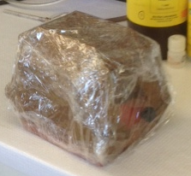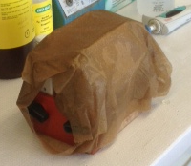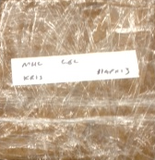

1. Loading/Running
2. Materials

* MHC gel
* Notched ceramic plate
* Cooling Unit (SE 260 Mighty Small II, basic)
* Clamps (red)
* 70 mL 5x MHC buffer
  + 35 mL 10x MHC buffer
    - 60.570 g Tris Base: Fisher, BP152-1
    - 56.303 g Glycine: MP, 808831
    - 5.00 g SDS: Bio-Rad, 161-0301
    - 1 L DI H2O
  + 35 mL DI H2O
* 1x MHC buffer
  + 100 mL 10x MHC buffer
  + 900 mL DI H2O
* 100 µL beta-mercaptoethanol: Bio-Rad, 161-0710
* Precision Plus Protein All Blue Standard: Bio-Rad, 161-0373
* Prepared samples
* 200 µL gel-loading pipette tips: USA Scientific, 1022-0600
* Spatula (No. 320, 45 mm): Nasuka, 420J2 HRC54

1. 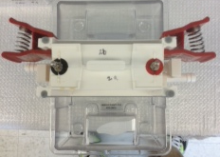Methods
2. Constructing the Cooling Unit

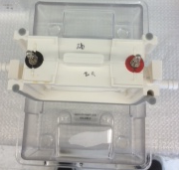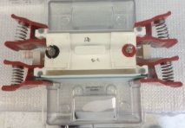Begin by assembling the cooling unit. The white apparatus should fit into the middle of the clear housing (it should click when it fits properly). Next, unwrap the stored gel from the saran wrap and paper towels. At this point, examine the gel for any structural defects. There can be no air bubbles in the gel. If any such space is present, the gels cannot be used.

1. Readying the Gel for Loading

Place the gel onto one side of the white chamber and secure it into place with two red clamps. On the opposite side of the white apparatus, secure a single notched ceramic plate using the other two red clamps.

Fill the cavity between the gel and the white apparatus (the upper chamber) with 70 mL of 5x MHC buffer (the level of the fluid should come up to the teeth of the comb). Next, **add 100 μL of BME to the upper chamber.** Fill the clear housing (lower chamber) with 1x MHC buffer until the fluid level has covered the notch present on both sides.

1. 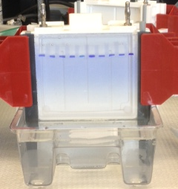Loading the Gel

Pull the comb out of the gel with caution so as not to rip the gel. With a 200 µL gel-loading pipette tip, use 30 µL of the upper chamber solution to flush out each lane prior to loading any sample. Then use these pipette tips to load each sample. It is common practice to load the standard(s) first (usually lane #5), then potentially a buffer sample in lanes #1 and #10 (for the gel’s structural integrity), and finally load your samples.

1. Running the Gel

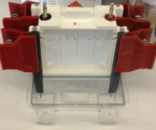With the samples loaded, place the cooling unit and cap it correctly with the hood. Make sure that the power supply is running at a constant current of 3 mA and set the voltage to the maximum value of 300 V. Set the timer for 24 hours and hit Start in order to run the gel. Reference the table below in order to gauge the running time for a gel.

|  |  |
| --- | --- |
| Voltage | Running Time |
| <160 V | 24 hours |
| 160-180 V | 18-20 hours |
| 180-200 V | 17-18 hours |
| >200 V | 17 hours |

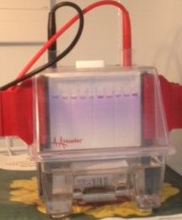

1. Readying the gel for staining

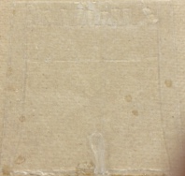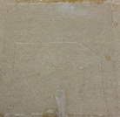Once the gel has been run, disconnect the chamber from the power supply. Pour out the solution into the sink and take out the gel from the assembly by removing the red clamps. Wedge the spatula in between the notched glass plate and the gel in order to remove the notched plate (the gel should be on the [non-notched] glass plate). Use the spatula to cut off the stacking gel, which is indicated by the crease in the gel. Afterwards, make a notch in the top right corner of the resolving gel.

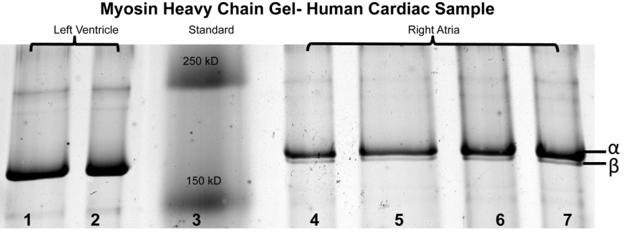Staining and Visualization

1. Silver Stain
2. Materials

* Fixative Enhancing Solution
  + 400 mL 100 methanol
  + 80 mL acetic acid
  + 80 mL Fixative Enhancer Concentrate: Bio-Rad, 161-0461
  + 240 mL DI H2O
* DI H2O
* 25 mL Development Accelerator Solution
  + 5.00 g Development Accelerator Reagent: Bio-Rad, 161-0448
  + 100 mL DI H2O
* 17.5 mL cold DI H2O
* 2.5 mL Silver Complex Solution: Bio-Rad, 161-0462
* 2.5 mL Reduction Moderator Solution: Bio-Rad, 161-0463
* 2.5 mL Image Development Reagent: Bio-Rad, 161-0464
* Silver Stain “stop” solution
  + 50 mL acetic acid
  + 950 mL DI H2O
* Power source (300 V, model 302)
* Refrigerator
* Spatula (No. 320, 45 mm)
* Gel staining box (11 cm x 11 cm x 3 cm)

1. Methods

* Fix: 20 minutes
  + 100 mL Fixative Enhancing Solution

While the gel is in the fixative enhancing solution, take the Development Acceleration Solution out of the fridge and pour out 25 mL so that it can reach room temperature.

* Wash: 2x10 minutes
  + 100 mL DI H2O

Begin mixing the silver stain solution during the gel’s last wash. Add the following reagents to a 50 mL beaker with a stirring rod in this exact order: 17.5 mL cold DI H2O (should be in the fridge), 2.5 mL Silver Complex Solution, 2.5 mL Reduction Moderation Solution, 2.5 mL Image Development Reagent, and 25 mL of (room temperature) Development Accelerator Solution.

* Stain: variable – must monitor carefully

When the gel has been sufficiently stained, remove the gel box from the shaker and manually pipette the silver stain into the silver stain waste container using a plastic transfer pipette.

* Stop Solution
  + 100 mL Silver Stain Stop Solution

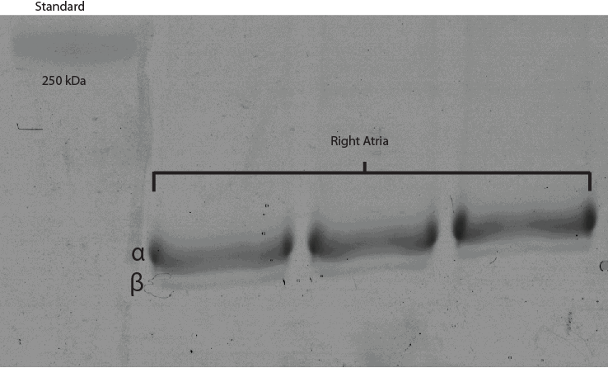

1. Coomassie G-250 Stain
2. Materials

* 0.2 g Coomassie Blue G-250
* 100 mL DI H2O
* 100 mL 2N H2SO4
* 22.2 mL 10 N KOH
  + 200 mL DI H2O
  + 112.2112 g KOH: Fisher, P-250-1
* 28.7 g TCA:
* Thermometer
* Heating plate
* Filtration flask/adapter

1. Methods

* Stain: variable (bands appear after 15 minutes)

Add the Coomassie powder to 100 mL DI H2O and warm it to 50°C. Cool to room temperature and add 100 mL 2N H2SO4. Incubate the solution at room temperature for at least 3 hours (no longer than overnight). Filter solution.

Add 22.2 mL 10 N KOH to the filtrate and then add 28.7 g TCA. Let the solution stand for at least 3 hours (filter again if necessary). Solution should be amber-brown without any blue precipitate.

When staining a gel, let the gel stain until the gel cannot be distinguished from the solution. Dispose of the Coomassie stain into an appropriate waste container. Do NOT aspirate!

* Wash: 2x10 minutes
  + 100 mL DI H2O

1. 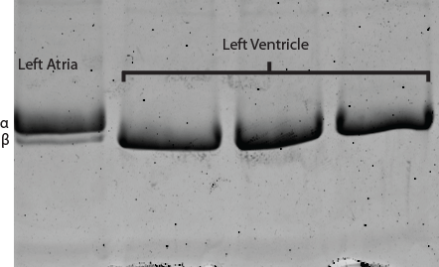Sypro Ruby Stain Sypro Ruby (Total time: ≥13.5 hours)
2. Materials

* 200 mL 50% methanol, 7% acetic acid
* 60 mL Sypro Ruby Stain: Invitrogen S-12000
* 100 mL 10% methanol, 7% acetic acid

1. Methods
2. Fix: 2x30 minutes

* 100 mL (Sypro Fixative Solution) 50% methanol, 7% acetic acid

1. Stain: >12 hours

* 60 mL Sypro Ruby stain

Dispose of the Sypro stain in its appropriately labeled waste container.

1. Destain: 30 minutes

* 100 mL (Sypro Destain Solution) 10% methanol, 7% acetic acid

1. Wash: 2x5 minutes

* 100 mL DI H2O